EPIC: Recipient Link Experience 3.0

Goal
Redesign the SpecterX recipient experience to support a more modern, scalable, and friction-reduced access flow centered around authenticated identity-based access using Microsoft and Google sign-in.
This initiative modernizes the recipient link experience beyond email OTP–only authentication and establishes the foundation for a more persistent, collaboration-capable recipient experience across files, folders, and future workspace interactions.
In addition to authentication improvements, this effort will unify several planned recipient experience enhancements into a consolidated Recipient Link Experience 3.0 initiative.
This work should leverage and reconcile prior UX concepts and partially completed designs from previous releases, including planned split-screen folder/file experiences and expanded recipient navigation patterns.
As part of this effort, UX must establish a dedicated Figma section and source-of-truth structure for Recipient Link Experience 3.0 flows and components.

Key Goals
- Introduce Google and Microsoft sign-in as alternatives to email OTP authentication
- Simplify recipient navigation and access flows
- Support scalable folder and multi-file viewing experiences

Supporting Experience Areas
This initiative may include updates related to:
- Link landing experiences and access to Shared with Me Page
- Share File Back/Request Files platform changes
- Future collaboration and workspace-aligned patterns

Recipient Authentication Flow Redesign (Microsoft & Google Sign-In)
Goal
Redesign the SpecterX recipient authentication experience to support federated authentication through Microsoft and Google sign-in as the primary authentication method when configured through policy.
This is a major recipient experience change that shifts the default access model away from email OTP–driven authentication toward a more modern identity-based sign-in experience. The updated flow should reduce recipient friction while maintaining clear governed access enforcement across all recipient entry points.
The experience must still support email OTP authentication as a fallback path for recipients who do not have or cannot use Microsoft or Google authentication.
This story focuses specifically on the authentication and pre-access flow leading into the recipient experience. It does not include the full redesign of the authenticated recipient page itself, but must account for how users enter and transition into that experience.

Core Experience Requirements
UX must design flows that support:
- Sign in with Microsoft
- Sign in with Google
- Fallback email OTP authentication
- Clear authentication method progression
- Identity verification prior to content access
- Smooth transition into recipient file or workspace experiences
The redesigned flow must support all primary recipient entry points, including:
- Standard shared file notifications
- Protected attachment banner experiences
- Protected email body experiences embedded within existing email threads
The experience should feel cohesive regardless of how the recipient arrives at the protected content flow.

Policy-Aware Authentication Flow
Authentication flows must reflect policy-driven security requirements.
If the applied policy requires additional authentication controls beyond federated sign-in, the experience must guide the user through these additional requirements before access is granted to files or Workspaces.
This includes support for:
- Phone verification
- Password authentication
- Additional layered authentication requirements configured through policy
UX should clearly communicate authentication progression and required next steps without creating confusion around why additional verification is being requested after sign-in.

UX Expectations
Designs should:
- Reduce recipient friction while preserving security clarity
- Reinforce trust and legitimacy of the access flow
- Clearly distinguish authentication versus content access
- Support mobile and desktop responsiveness
- Consider returning recipient continuity and session expectations
- Account for fallback and error-handling scenarios
This work should align with the broader Recipient Link Experience 3.0 initiative and leverage prior recipient experience concepts where applicable.

Definition of Done
- UX flows are created for Microsoft and Google sign-in authentication
- Email OTP fallback flows are incorporated into the experience
- Authentication progression reflects policy-driven requirements
- Additional authentication requirements (phone/password) are represented before access is granted
- All primary recipient entry points are considered in the flow design
- Mobile and desktop experiences are addressed
- Recipient transition into authenticated experiences is cohesive and intentional
- Designs are added to the Recipient Link Experience 3.0 Figma structure

Recipient Page Layout Simplification & Navigation Redesign
Goal
Redesign the authenticated recipient experience to provide a simpler, more intuitive navigation and content interaction model across files, folders, and Workspaces.
Today, recipient navigation and file interaction patterns rely too heavily on contextual layouts and collapsed panels, making actions difficult to discover and creating inconsistent experiences depending on how content is shared. This redesign should simplify the experience, improve visibility of file controls, and establish clearer differentiation between shared content types.
The redesigned experience should:
- Provide a consistently visible route back to the “Shared with Me” experience across all recipient flows
- Simplify navigation and reduce unnecessary UI complexity
- Improve visibility and accessibility of file actions and controls instead of hiding them within collapsed interface sections
- Create clearer visual differentiation between files, folders, and Workspaces
- Introduce dedicated Workspace presentation patterns and iconography so Workspaces are visually distinct from standard folder shares
This work should support both first-time and returning recipients while creating a scalable foundation for future collaboration and recipient experience expansion.
Designs should align with the broader Recipient Link Experience 3.0 initiative and leverage prior planned concepts where applicable, including split-screen viewing experiences.

Definition of Done
- Simplified recipient navigation concepts are delivered
- “Shared with Me” access is consistently available across recipient experiences
- File controls and actions are more visibly accessible
- Folder and Workspace experiences are visually differentiated
- Workspace iconography and presentation patterns are defined
- Mobile and desktop layouts are considered
- Designs are incorporated into the Recipient Link Experience 3.0 Figma structure

Backend Support Requirements

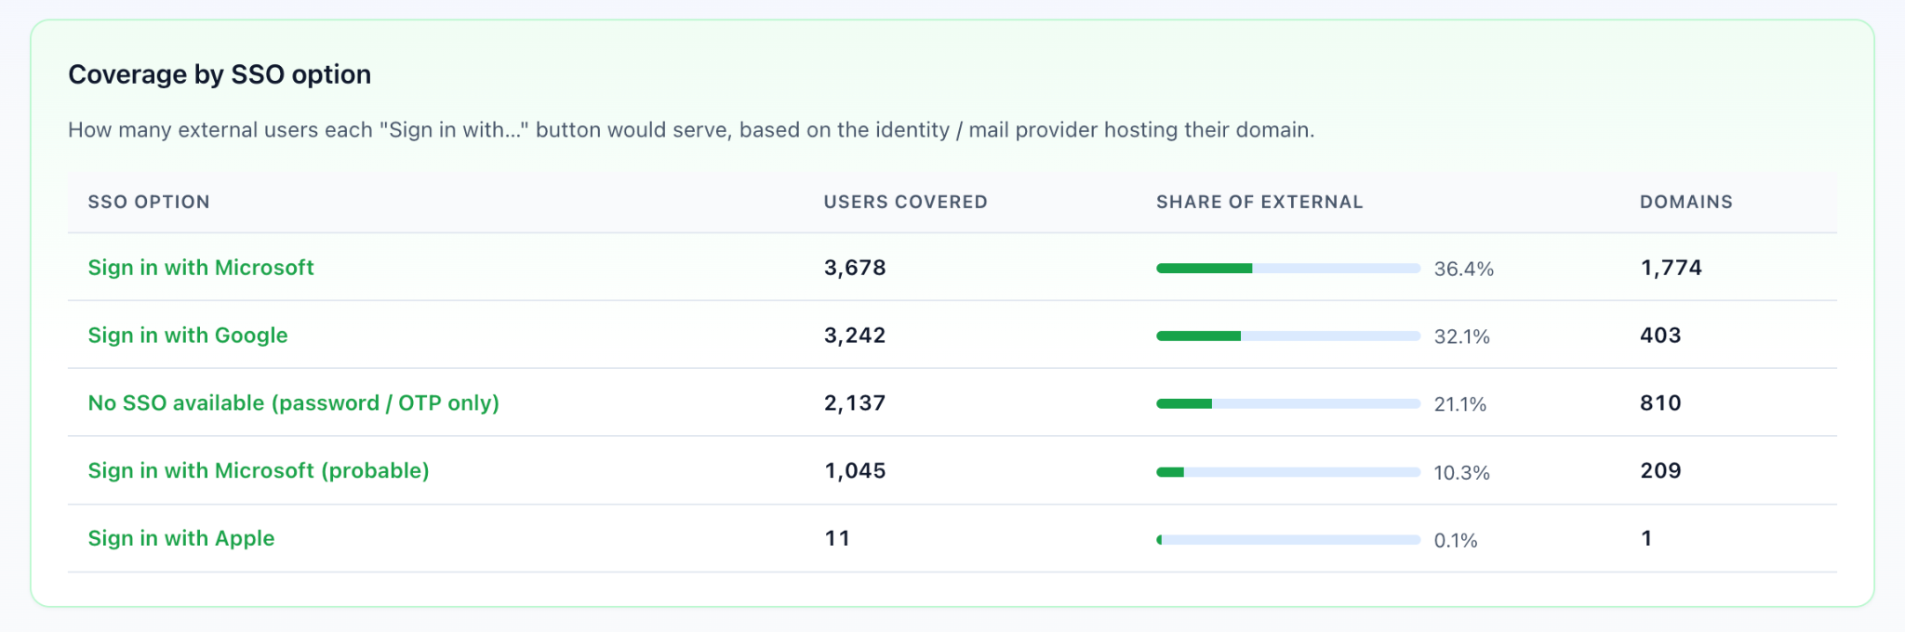

Notes with Shahar:

